**MOST EXPENSIVE CLIMATE AND WEATHER DISASTERS IN USA**

**INTRODUCTION:**

Graphs are a commonly used tool for visualizing data and conveying information clearly and efficiently. However, creating effective and accurate graphs requires following best practices in data visualization. When these guidelines are not adhered to, graphs can be misleading, confusing, or even downright inaccurate. Data visualization is a powerful tool for communicating information, but poor design choices can easily distort the data being conveyed. This project report examines examples of poorly designed graphs and redesigns them to illustrate more effective and appropriate visualization methods. These problems may include ambiguous labels, improper scaling, overlooking context, and unnecessary embellishments. The redesigned alternatives will demonstrate solutions and best practices that could have improved the graphs. These solutions may involve changes like selecting a more suitable chart type, rescaling axes, adding descriptors and units, or simplifying unnecessary visual elements.

**BAD GRAPH:**

The United States has a history of facing expensive natural disasters that have far-reaching economic and societal consequences. Understanding the most expensive natural disasters in the USA is crucial for disaster preparedness, mitigation, and recovery efforts. Exploring the costliest natural disasters in the country can shed light on the financial impact of these events and help policymakers and communities better prepare for future disasters.

**Source:** The source for the bad graph on the most expensive climate and weather disasters in USA is from the following site: <https://howmuch.net/articles/most-expensive-naturals-disasters-in-usa>. The article provides data and analysis on the costliest natural disasters that have occurred in the United States.

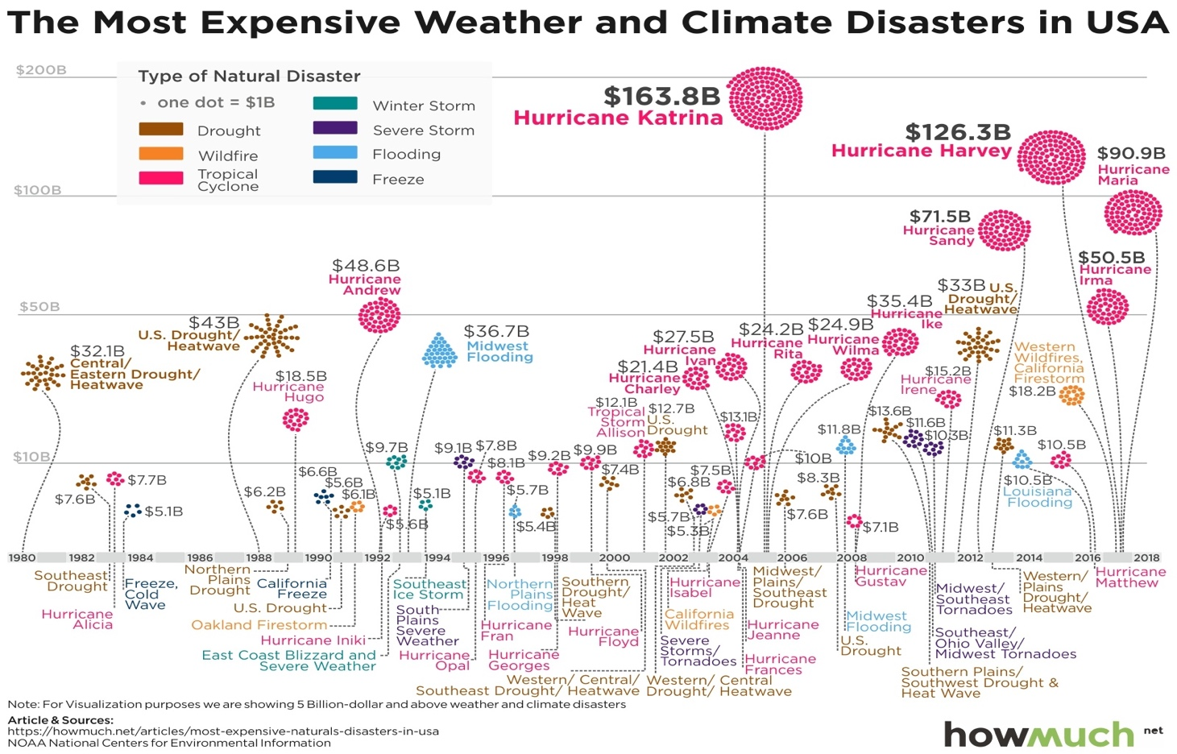

Figure 1. Bad Graph on most expensive climate and weather disaster in USA

**Context:** The source offers a comprehensive analysis of the most expensive natural disasters in the USA. It categorizes these disasters into various types, including hurricanes, wildfires, floods, and earthquakes. The article provides context by discussing the financial toll these events have taken, encompassing costs related to property damage, infrastructure repair, and insurance claims. Additionally, it explores the economic consequences and implications for disaster preparedness and response.

**Strength:** The graph provides a proper distinction between the types of disaster. To highlight the most expensive disasters, the data has been filtered to only show disasters costing over $5 billion. This filtering provides a clear view of the topmost expensive disasters.

**Weakness:** The graph attempts to depict the cost of all natural disasters from 1980 to 2020. Each dot represents $1 billion in damage costs. However, showing each dot as $1 billion is unnecessary since the costs are also listed along the y-axis. The graph does not provide information on which types of disasters were most costly for each region. The disaster names are aligned in a way that is unclear to readers. The y-axis only shows the total costs and does not indicate which years saw the highest disaster costs. The intervals along the x-axis are too broad to accurately match specific disaster events with their costs. Overall, the information is not organized in a way that allows readers to easily determine the most financially devastating natural disasters within the period.

**RE-DESIGNED GRAPH:**

**Objective:**

The objective of the redesigned graphs is to clearly visualize the most expensive weather and climate disasters that occurred in the United States from 1982 to 2022, with a focus on highlighting the top 5 highest costing events. The new graphs will neatly present the specific names, years, and costs associated with each major disaster in a readable format, unlike the cluttered original dot chart. They will also categorize the different types of disasters, such as hurricanes, floods, and storms, and use color coding or legends to distinguish between these event types. The goal is to enable easy identification of the most catastrophic and costliest disasters over time, as well as analyze any trends by disaster type or year. Overall, the redesigned graphs aim to organize the major weather disaster cost data in the US during the 1982-2022 period in a clean and comprehensible way to improve understanding and insights compared to the messy original visualization.

**Data Source:**

The data presented in this paragraph is sourced from the National Centers for Environmental Information (NCEI), a part of the National Oceanic and Atmospheric Administration (NOAA). The NCEI is a renowned organization dedicated to collecting, managing, and providing access to a vast repository of environmental data. The link provided offers information on various disasters that have occurred in the United States from 1982 to 2022. The data on natural disasters in the United States from 1982 to 2022 was sourced from the National Centers for Environmental Information (NCEI) and can be accessed at: [Billion Dollar Weather and Climate Disaster.](https://www.ncei.noaa.gov/access/billions/events/US/1982-2022?disasters%5b%5d=all-disasters.)

**Software Solutions:**

Two critical software solutions come into play when reworking a poorly built graph. To begin, R is used to efficiently format and manipulate data, allowing users to restructure and clean it for different graph kinds. R's adaptability in data processing makes it an effective tool for data transformation and preparation. Tableau is then used to visualize the data in a more effective and aesthetically acceptable way. Users may generate visually stunning graphs and integrate them into dynamic dashboards using Tableau's interactive and user-friendly interface, improving the overall accessibility and comprehensibility of the data. This combination technique of R and Tableau ensures that a terrible graph is successfully transformed into an instructive and appealing data display.

***R Studio:*** The underlying data is unstructured and unordered. To clean the data, R packages such as *tidyverse*, which incorporates all the functionality of *dplyr* and *tidyr*, are employed. The data is also sorted and organized in a way that makes it easier for tableau to use in data display. *Appendix A* shows the data before and after processing with R studio. *Appendix B* contains the R code used to perform the data manipulations described above.

***Tableau:*** Tableau's graphing skills were used to clearly depict the revised data, with customizable axes, data labels, color coding by disaster type, and annotations to flag out noteworthy points. Tableau's interactive dashboards provide deeper analysis by allowing users to drill down into the data. Overall, Tableau provides the tools to transform the chaotic source data into a clear, meaningful visualization.

**Cognitive Testing Questions:**

**Questions:** What is your preference between Plot 1 and Plot 2? What elements from each plot do you like to use and discard? Does the plot convey the meaning of the study? What do you understand from the plots? Do you think the information provided in the plot is sufficient or is there any elements that can be added or improved? How does the visual elements in the plot affect your ability to interpret the data?

**Reviewer Feedback:** The reviewer offered thoughtful insights on my data visualization plots, indicating a preference for Plot 2 over Plot 1 due to its effective descending order display of disaster expenses, making it easy to identify highest costs. Critically, they found no elements in either plot that should be discarded, confirming all components have value in conveying the core message about climate disaster expenses from 1980-2018. The reviewer demonstrated accurate understanding of the plots' purpose and intent, reassuring that the message was effectively communicated. They were satisfied with the level of clear, concise information provided, praising specific visual choices like color-coding, and labeled expense amounts as aiding accurate data interpretation.

**Resulting Design Change:** After receiving positive feedback from the reviewer, no changes have been made to the graph at this time. The reviewer did not recommend any modifications or potential design improvements, so the graph will remain in its current form. As the feedback was favorable, it was deemed unnecessary to adjust the graph further. However, if any design change suggestions arise in the future, they will be taken into consideration.

*Appendix C* contains the Plot 1 and Plot 2 mentioned in the testing questions.

**Challenges:**

The vast volume of disaster data that needed to be visualized posed the most difficult obstacle while rebuilding the graph. A single graph could not properly describe the large dataset. To solve this, the data had to be meticulously altered and analyzed to discover the most important elements and trends. Creating clear, distinct graphs and visualizations that effectively communicated the lessons contained within the voluminous disaster data demanded careful data structuring. Some nuance and detail had to be sacrificed for the sake of graphical clarity. The resulting graph shows a selectively filtered subset of the data in a visually appealing way that emphasizes the most important characteristics while remaining understandable. When condensing the data, careful data manipulation was required to balance detail with visual clarity.

**Redesigned Graph Improvements and correspondence to class design principle:**

The new graph incorporates several enhancements that adhere to the principles of effective data visualization taught in class. The new graph only displays the costliest calamity each year, reducing visual clutter. Color coding and labeling distinguish disaster types, which helps comprehension. Annotating precise spending values for the top disasters improves precision. The five most expensive disasters draw attention to critical data pieces. Overall, the new graph streamlines the display, improves clarity, and comprehension. The improvements emphasize basic class principles such as reducing extraneous features, intentionally using color, labeling relevant data points, and stressing major patterns or relationships. The redesign decisions reflect determined best practices for data visualization aimed at providing an intuitive, relevant graph.

**Patterns in redesigned Graph:**

Several patterns emerge from the disaster cost data visualized in the redesigned graph. First, hurricane/tropical storm damage consistently ranks among the costliest disaster types, with major hurricane destruction seen in 2005, 2012, 2017, and 2018. Flood events also tend to incur high costs, occurring frequently throughout the timeline. The redesigned graph highlights that 2017 stands out as an especially devastating year, with massive hurricane, flooding, and wildfire expenses. Additionally, the highlighted top 5 costliest disasters illustrate that major hurricanes like Katrina and Sandy caused unusually extreme damage. Over the 40-year period, clear periodic spikes representing the most catastrophic events appear, while the disaster type color-coding demonstrates that the damage from floods, hurricanes, and storms account for the highest disaster costs year-over-year. Tracking these cost patterns provides insight into the evolving profile of the most severe and expensive disaster events in the U.S. over recent decades.

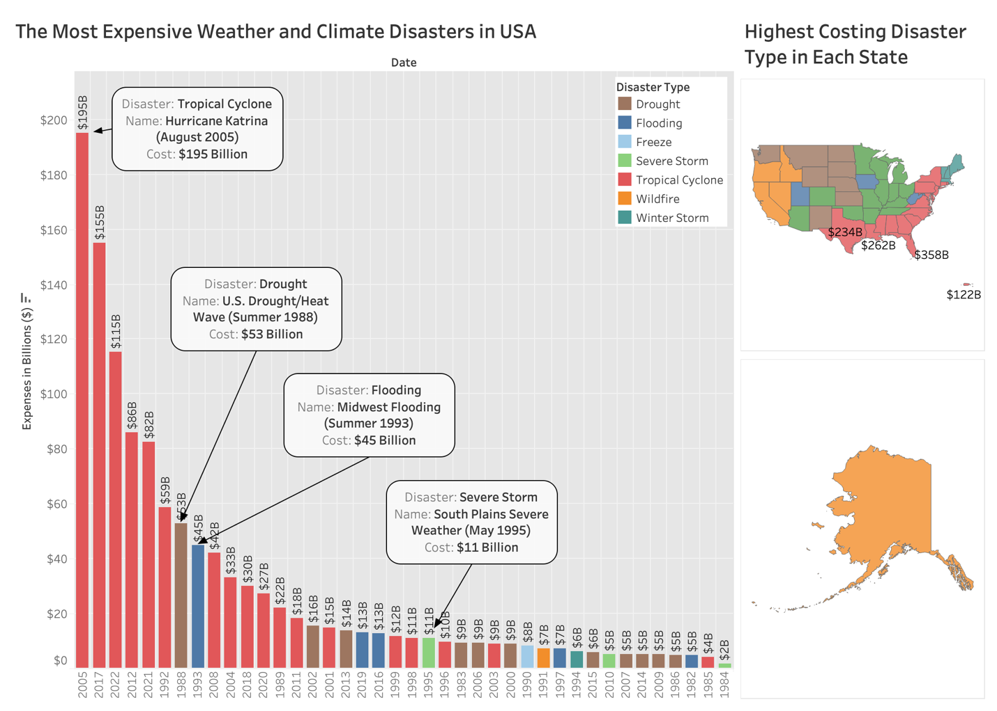

Figure 2: Final Re-designed Visualization

**CONCLUSION:**

The original graph attempting to chart the most expensive U.S. natural disasters from 1980-2020 had significant issues that made the data difficult to parse and comprehend. By focusing the redesign on core data visualization best practices covered in class, such as eliminating nonessential details, using color deliberately, adding labels, and highlighting key data points, the new graph delivers substantially increased clarity and insight. Thoughtful data manipulation and strategic visual encoding choices allow important cost patterns and outliers to emerge. The redesigned disaster cost graph simplifies the visual display and enhances understanding of the most impactful and expensive U.S. disaster events over the past four decades. Applying sound data visualization principles transformed an overly complex graph into a streamlined, intuitive, and insightful chart.

**REFERENCES:**

OpenAI. (2023). ChatGPT. San Francisco: OpenAI.

Paraphrasing – QuillBot

*Visualizing the most expensive natural disasters in the last 40 years*. (2018, May 29). HowMuch. <https://howmuch.net/articles/most-expensive-naturals-disasters-in-usa>

NCEI.Monitoring.Info@noaa.gov. (n.d.). *Billion-Dollar Weather and Climate Disasters | National Centers for Environmental Information (NCEI)*. <https://www.ncei.noaa.gov/access/billions/>

**APPENDIX A: DATASET**

**Raw Dataset:**

Sample Dataset showing all the disaster events between 1982-2022

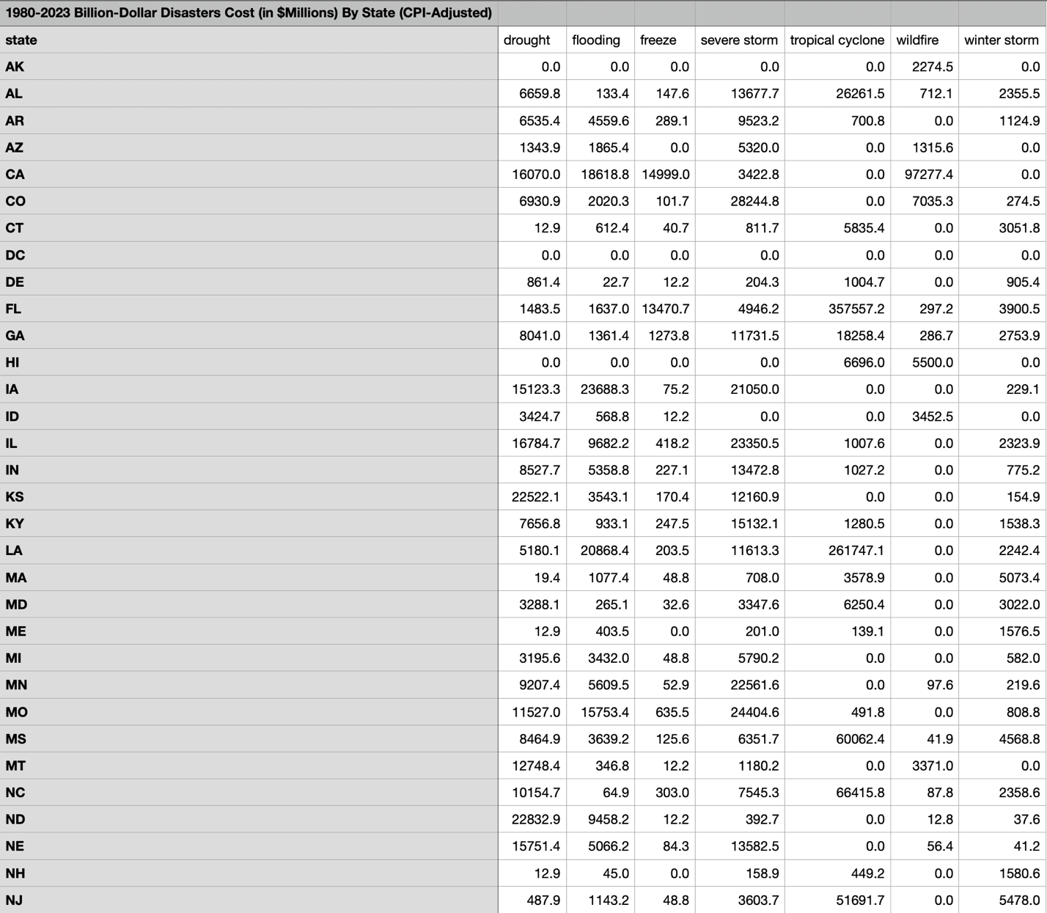

Sample Dataset showing the disaster costs in each state based on types.

**Processed Dataset:**

Sample Processed Dataset showing the costliest disaster in each year between 1982-2022.

Sample Dataset showing the costliest disaster type in each state.

**APPENDIX B: R CODE**

**R Code to transform the data for visualization:**

**APPENDIX C: Tableau Plots**

**Plot 1:**

**Plot 2:**

